DEPATMENTAL PROFILE

1.NAME OF THE DEPARTMENT SOCIOLOGY
2.YEAR OF ESTABLISHMENT 1982
3.DEPARTMENTAL E-MAIL ID sociology1982@gmail.com
4.PROGRAM OFFERED U.G.AND P.G
5.STAFF DETAILS: SANCTION POST 04
FILLED POST 02
VACANT POST 02
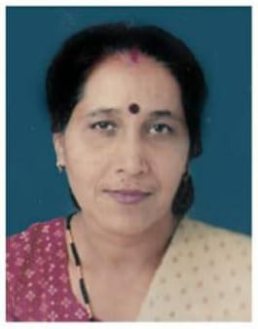
6.TEACHING STAFF
NAME Dr.MEENA PATHAK
- E-mail ID meena10pathak@gmail.com
- SPECILIZATION folkculture
- NO. OF PUBLICATION NIL


- NAME RANJANA POOJA YADAV
- E-mail ID poojashakti1234@gmail.com
- SPECILIZATION Sociology
- NO. OF PUBLICATION NIL

7. LAB TECHNICIAN NIL
8. LAB BEARER NIL
9. STUDENT STRENTH
UG | PG | RESEARCH
125 | 20 | NIL

10. SWOC ANALYSIS
- Strengths
*Support system for slow learner
*Emphasis on holistic development of students
*Well qualified competent and experienced dedicated teachers

- Weaknesses
*Maximum students are from rural background so it is difficult to improve their communication skill.

- Opportunities
*The college is situated in the centre of the city so that transportation facility is available anytime

- Challenges
*To work more for extension activity to strengthen our bonding with neighbor community.

